CSA-0805-PYTHON PROGRAM
LEVEL- 1
NAME:-A.Thrilokesh DATE:-/11/25
REG NO:-192425098 SUBJECT:-Python

1.Write a Python program to display most and least significant digit of a
number.
Sample Input :
1267899
Output:
LSB : 1 &amp; MSB : 9

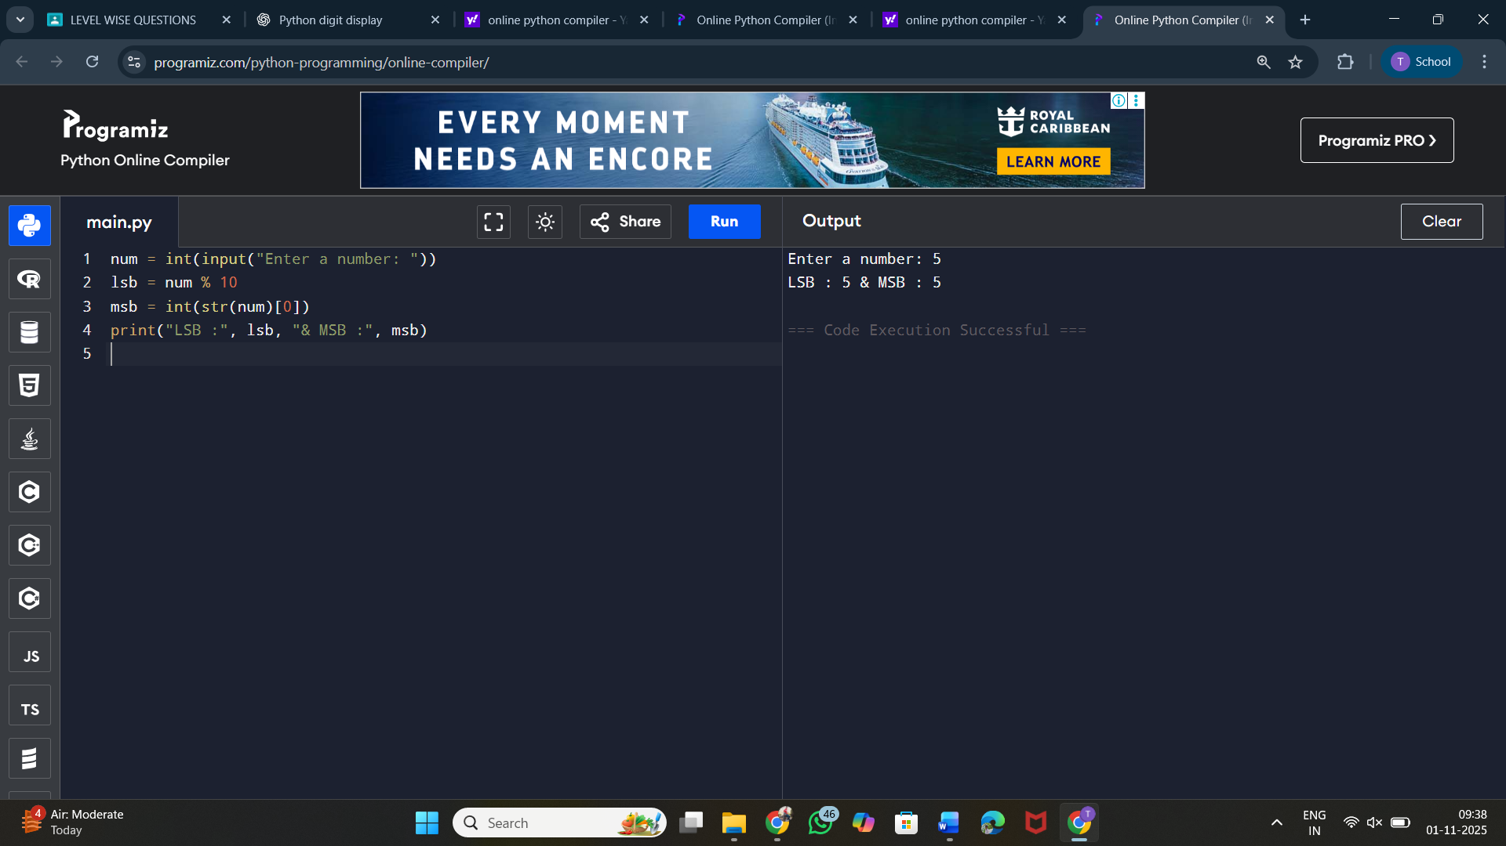

2. Given a positive integer N. The task is to find 12 + 22 + 32 + ….. + N2.
Sample Input: n = 4
Output: 30

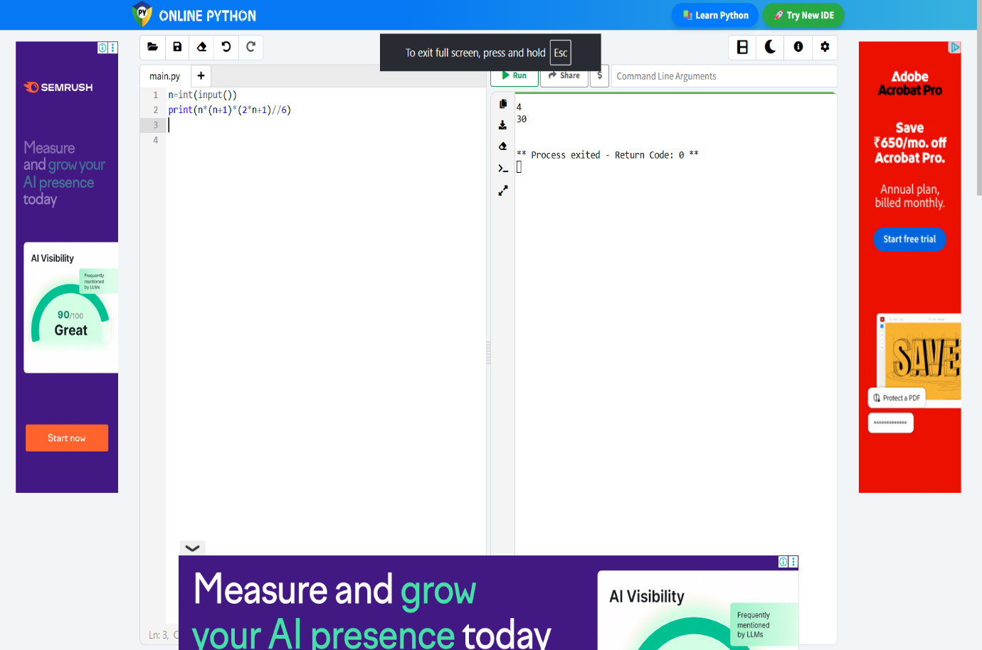

3.Check whether a number is Tech Number or not
Sample Input: n = 2025
Output: True

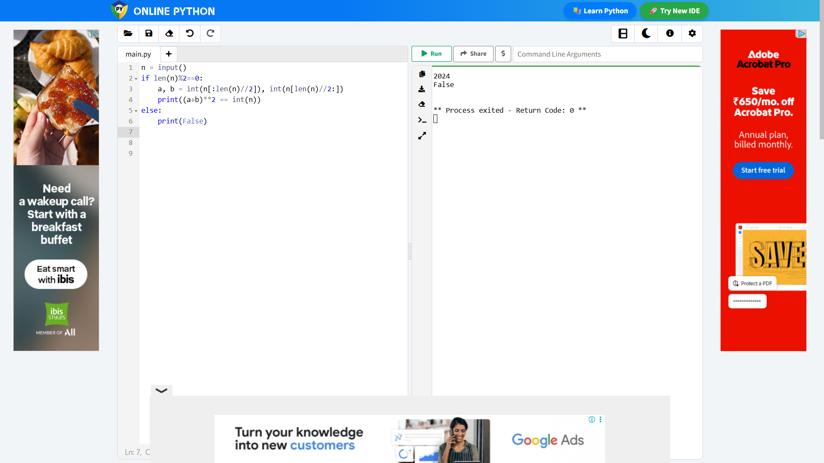

4. Write a Python program to convert decimal to binary number
Sample Input : 7
Output :111
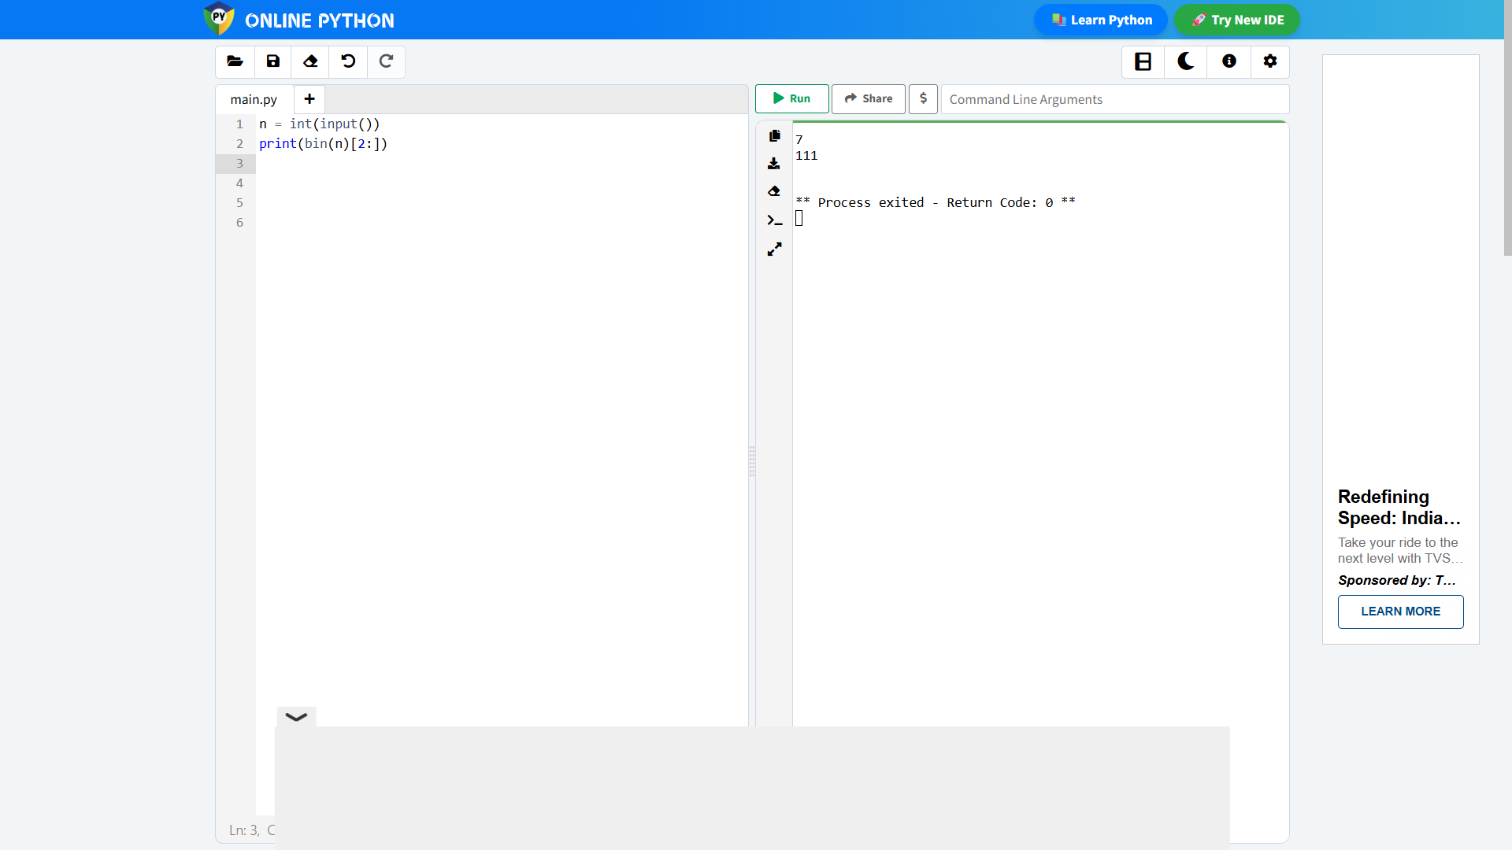

5.Write a Python Program to print all Possible Combinations from the three
Digits
Input: [1, 2, 3]
Output:
1 2 3
1 3 2
2 1 3
2 3 1
3 1 2
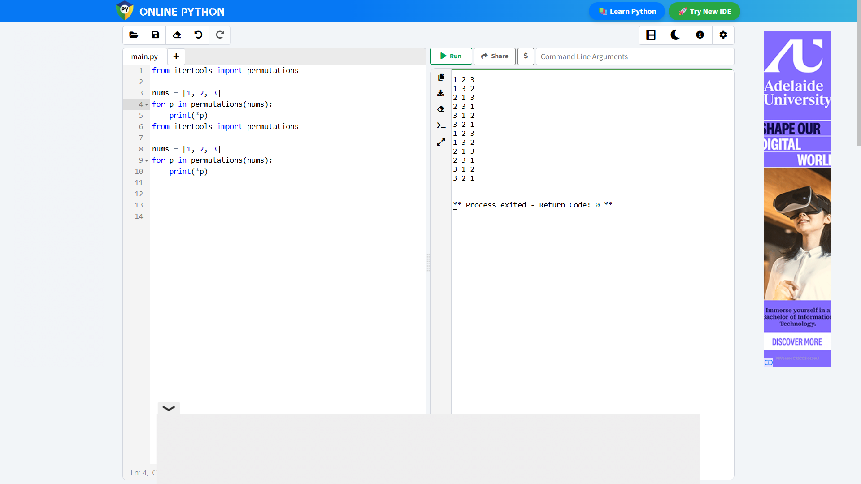
3 2 1

6. In a daily share trading a buyer buys shares in the morning and sells them on
the same day if the trader is allows to make at most 2 transactions in a day
where as the 2 nd transaction can only start after the 1ts one is completed(buy-
&gt;sell-&gt;buy-&gt;sell).given stock price through out the day. Find ot the maximum
profit that a share trader could have made
Sample Input:
Prices=[7,1,5,3,6,4]
Output:7
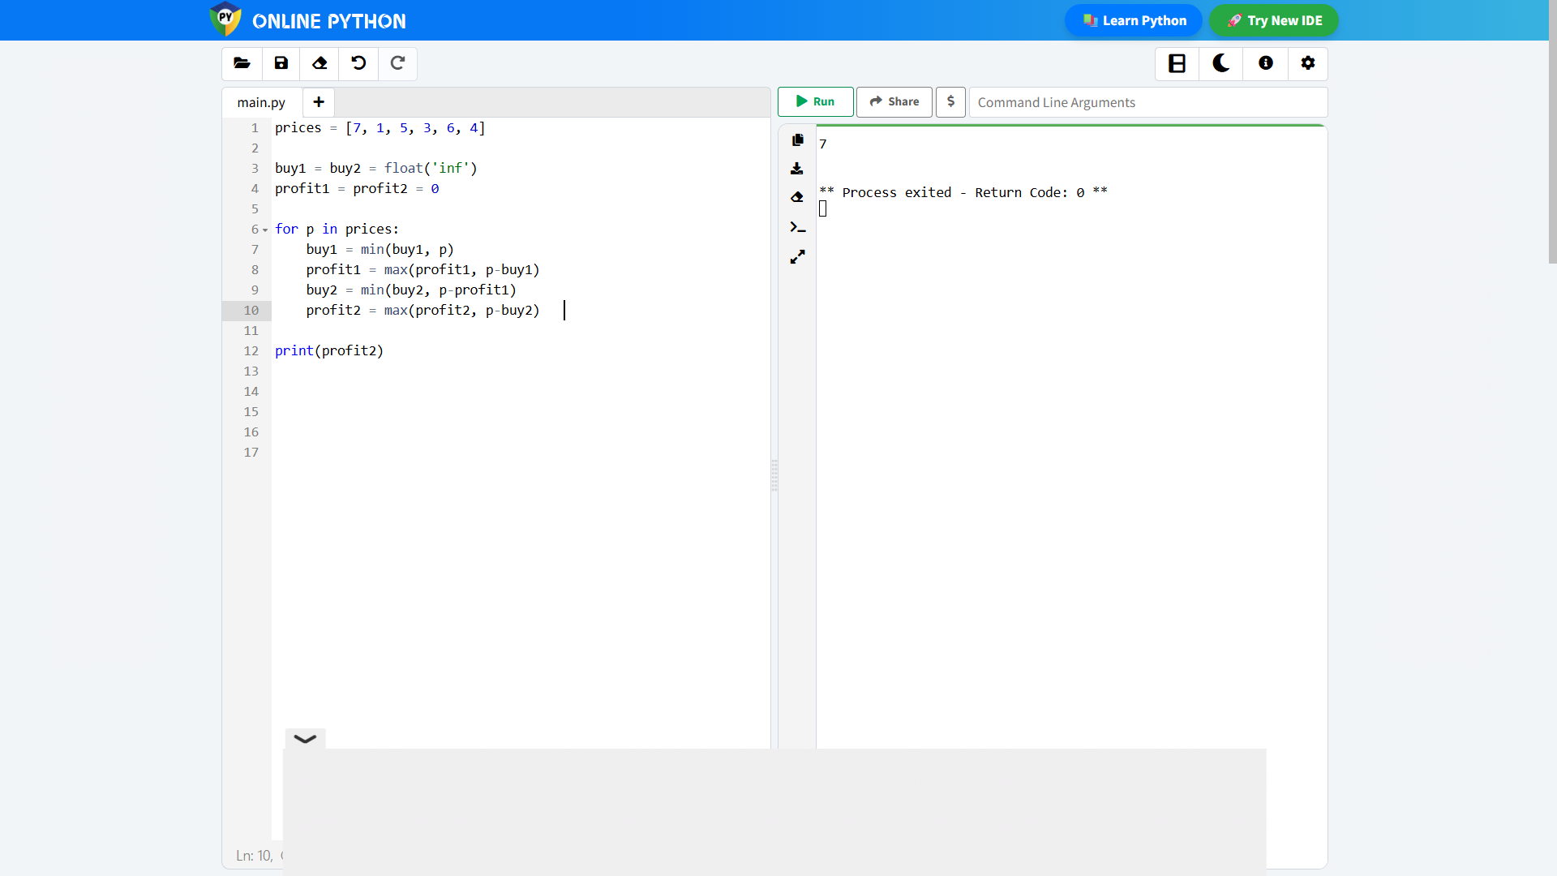
7. Suppose an array of length n sorted in ascending order is rotated in between 1
and n times
Sample Input:
nums =[0,1,4,4,6,7]
Output:
[4,5,6,7,0,14] it was rotated 4 times
[0,1,4,4,5,6,7] if it was rotated 7 times
Notice that rotating an array [a[0], a[1],a[2],…a[n-1]] 1 time result in the array
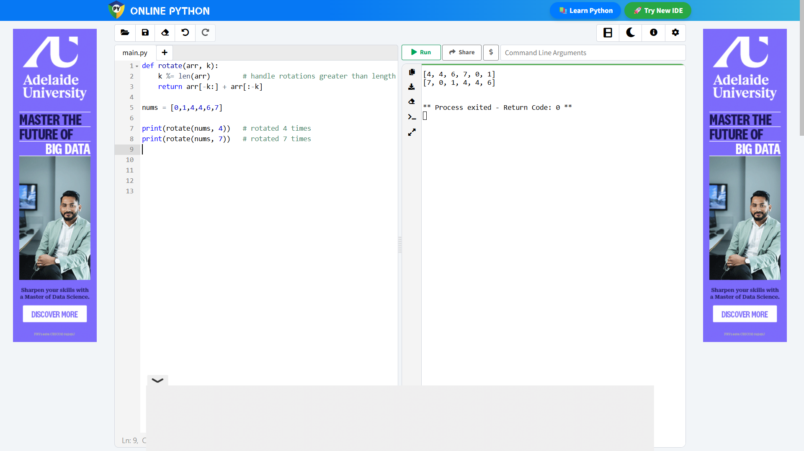
[a[n-1],a[0],a[1],a[2],…,a[n-2]].

8. Given an array of integers num sorted in non-decreasing order, find the
starting and ending position of given target value if target is not found in the
array, return[-1,-1]
Sample Input:
nums =[5,7,7,8,8,10]
Target=8
Output: [3,4]
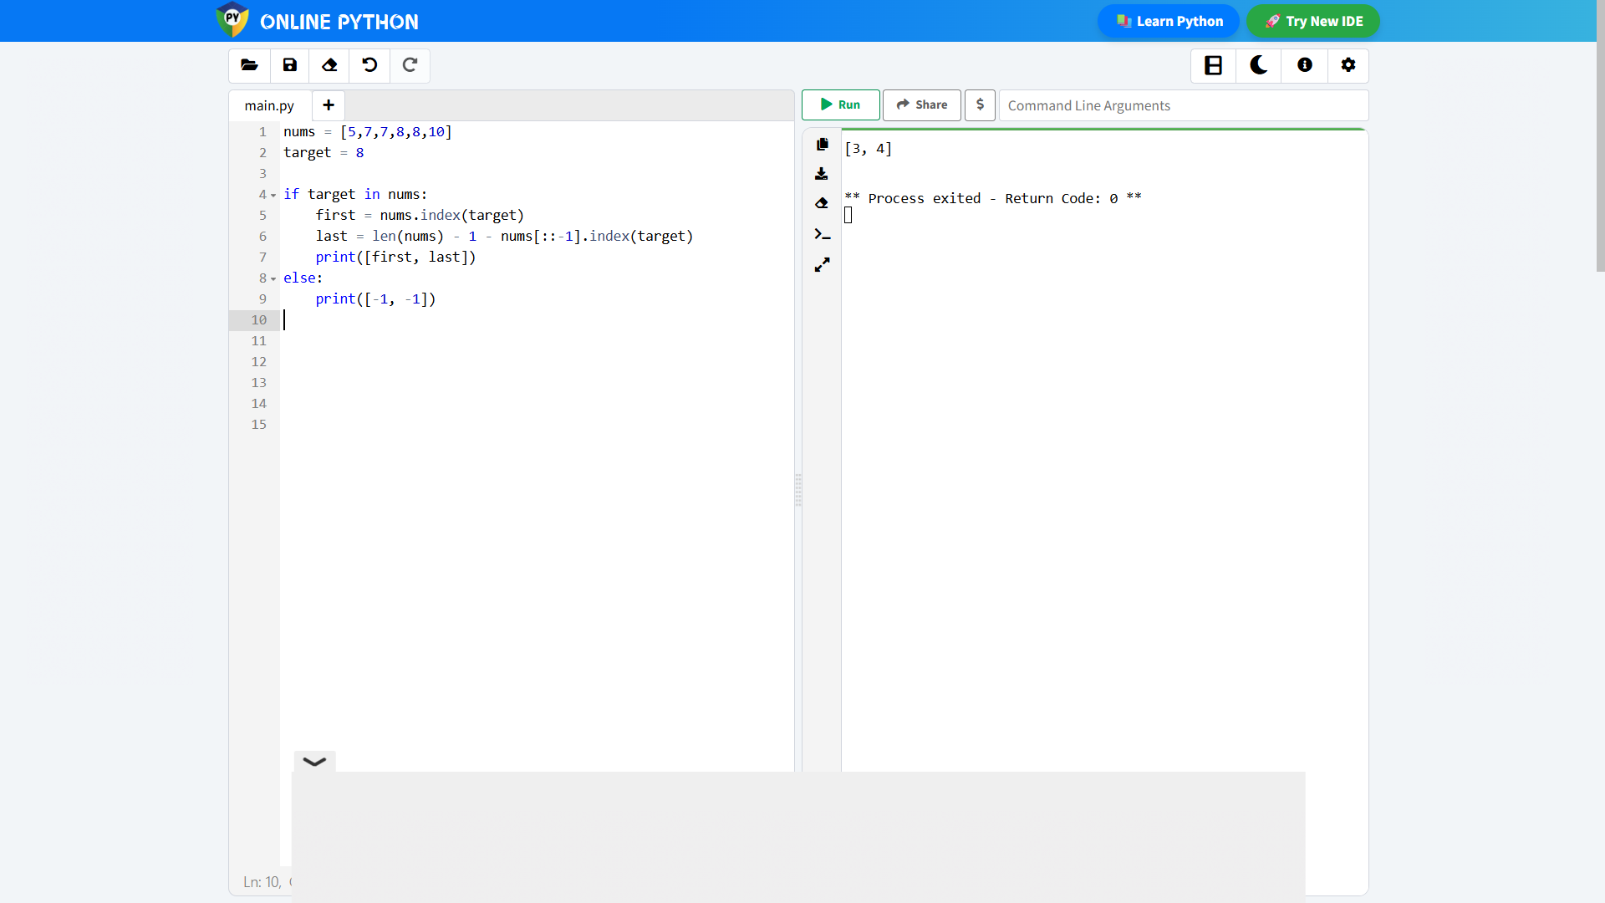

9. Given string num representing a non-negative integer num, and an integer k,
return the smallest possible integer after removing k digits from num.
Example 1:
Sample Input: num = &quot;1432219&quot;, k = 3
Output: &quot;1219&quot;
Explanation: Remove the three digits 4, 3, and 2 to form the new number 1219
which is the smallest.
Example 2:
Sample Input: num = &quot;10200388&quot;, k = 1
Output: &quot;200388&quot;
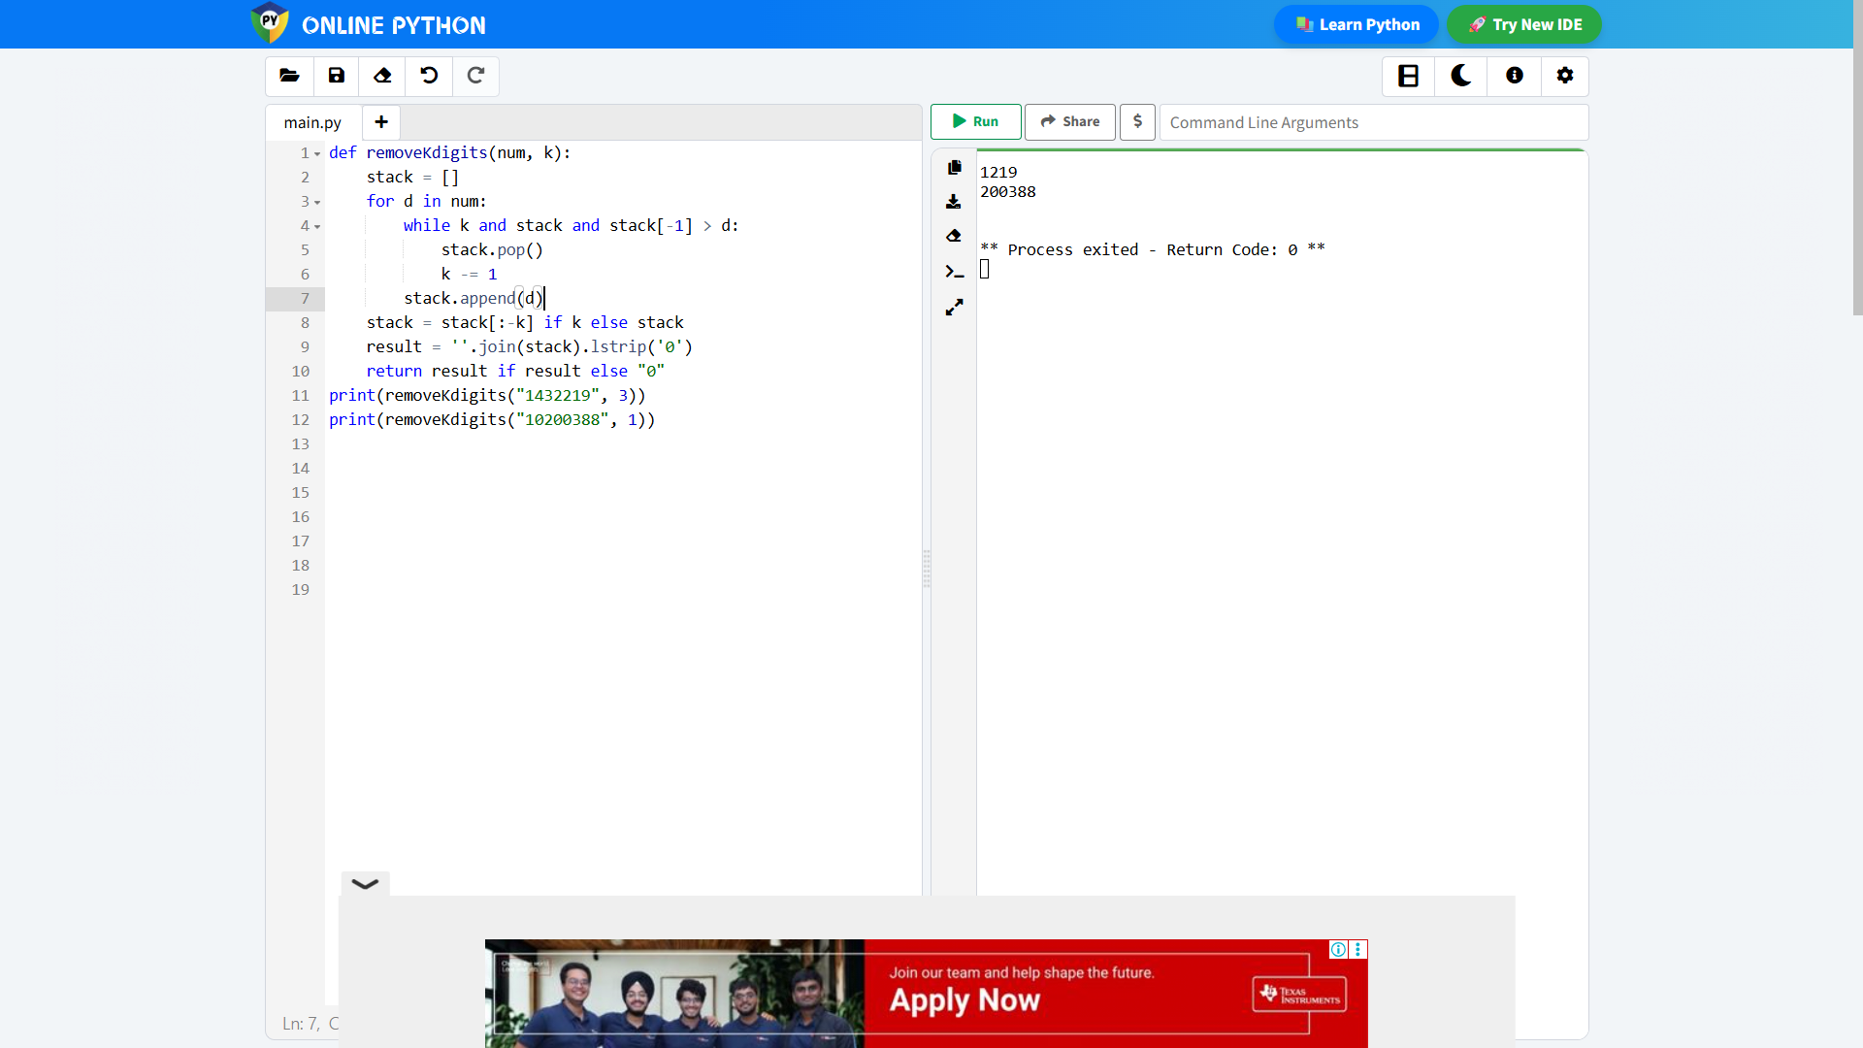

10. Write a Python program to print a matrix in spiral order. Given an m x n
matrix, return all elements of the matrix in spiral order, starting from the top-

left and moving inwards.
Spiral Order Definition:
In spiral order traversal, you visit all elements of the matrix starting from the
top-left corner and proceeding in a circular, clockwise direction, layer by
layer.
Sample Input:
1 2 3
4 5 6
7 8 9
Output:
[1, 2, 3, 6, 9, 8, 7, 4, 5]
